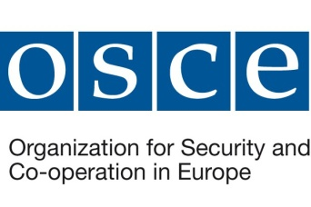 | 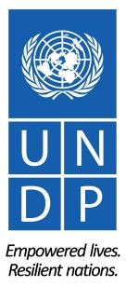 |  | 

GEF Project
“Enabling Transboundary Co-Operation and Integrated Water Resources Management in the Dniester River Basin”

Working Meeting of the Expert Group

on the Analysis of the Impact of Dniester HPP Reservoirs on the Status of the Dniester Basin

Chisinau, Republic of Moldova
14 September 2018

Meeting Summary

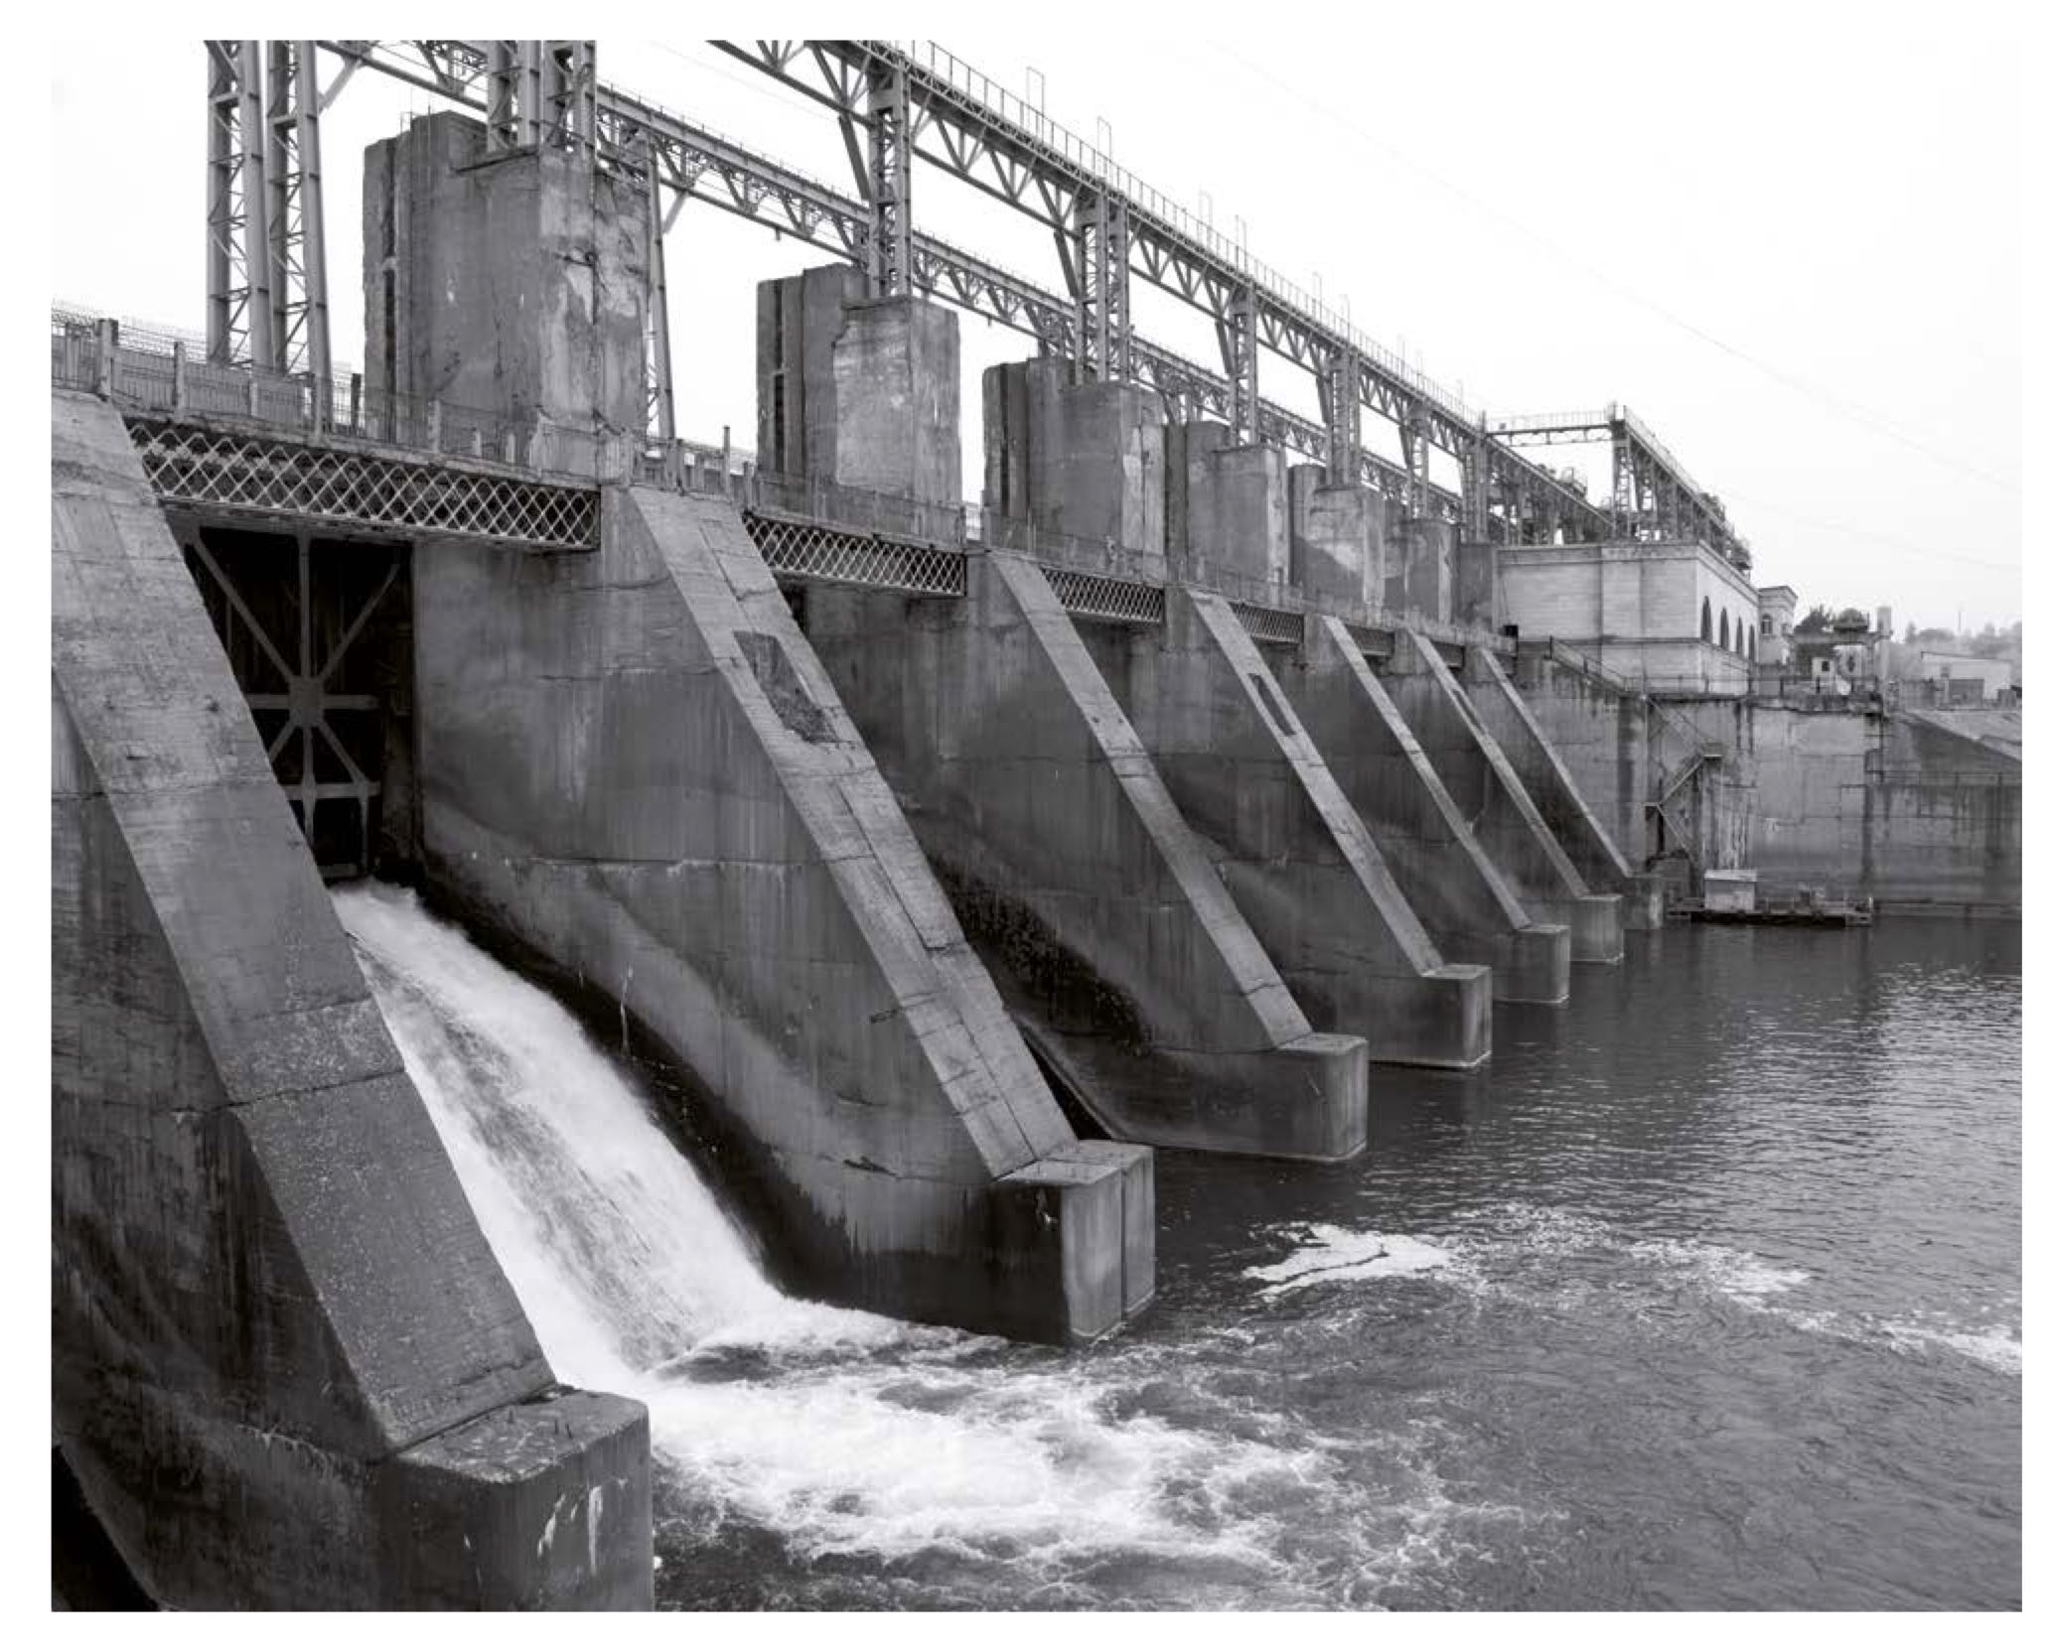
© Shutterstock

Overview

The second working meeting of the expert group on the analysis of the impact of Dniester HPP reservoirs on the status of the Dniester River basin took place at Aria Hotel in Chisinau. The meeting agenda is provided in Annex 1. The meeting was attended by 14 experts of research and project institutions, NGOs, natural resources management organisations, environmental protection and other state organisations of the Republic of Moldova and Ukraine, and 6 representatives and consultants of international organisations (Annex 2).

The objective of the meeting was to present and discuss the progress and interim results of work from the time of the previous meeting on 18 – 19 June 2018 in Kyiv, including the current status, agreed methods of analysis and data sources in thematic sub-groups, first preliminary results of the analysis, and next steps.

Hydrological Changes

A preliminary analysis of data from Zaleschiki, Mogilev-Podolsky and Bender gauging stations pursuant to the recommendations of Guidance Document No. 31 implementing the EU Water Framework Directive showed significant changes in the intra-annual flow variability both over time (above the Dniester hydropower complex due to long-term climate changes; below the Dniester hydropower complex and below the Dubasari reservoir when comparing the periods before and after the construction and commissioning of the reservoirs) and along the Dniester River in the modern period after the reservoirs have been commissioned.

While climate changes caused an increase in the maximum and the minimum flow (by 2– 4% and 18 – 73%, respectively, at Zaleschiki gauging station), the impact of the reservoirs in their lower reaches has led to a systematic reduction in the maximum spring flow (except for May, based on the data from Bender gauging station) by 15–25% and an increase in the minimum flow by 35% to 100% or more, depending on the averaging period. The same characteristics are observed when comparing data from different gauging stations during the modern period of 1991 – 2015: an increase in the minimum and a decrease in the maximum flow in Mogilev-Podolsky compared to the total inflow to the Dniester HPP-1 reservoir and in the river section at Bender gauging station compared to that in Mogilev-Podolsky. The general pattern is a decrease in the absolute value of changes with an increase in the averaging period.

The further work is expected to include the analysis of

- characteristics of the hydrological regime for shorter periods: after the launch of HPP-1 and the operation of the HPP-2 reservoir in a buffer regime without the operation of HPP-2; after the launch of the HPP-2 (1999 – 2002) and before the launch of the PSPP (1st unit – late 2009); and during 2012 - 2018, after the commissioning of the upper reservoir of the PSPP;
- diurnal operation mode and water flow below HPP-2;
- long-term Dniester flow variations based on the data from Bender gauging station (1881 – 2015) for the purpose of determining the cycles and phases of river flow variability;
- characteristics of a spring flood regime before the construction of the reservoirs when compared to the regime of the modern annual ecological reproductive water release;
- water balance of HPP-1 reservoir for the years of its operation and its comparison with the water balance of the Dniester River below the HPP-2 reservoir.

Changes in the Hydrochemical and Hydrobiological Regimes and the Status of Riparian Ecosystems

Based on the decisions adopted at the First Expert Group Meeting in June 2018 and taking into account the EU methodological experience and similar studies conducted in the Danube and the Rhine basins, the analysis of hydrochemical (and hydrophysical) changes was focused on the dissolved oxygen concentration in water, its temperature and – to charachterise changes in the flow of sediments – the turbidity of water (concentration of suspended solids). The analysis is based on the information provided by the Ukrainian Hydrometeorological Centre, the State Hydrometeorological Service of Moldova, and the Hydrometeorological Centre of Tiraspol and obtained from Zaleschiki, Naslavcea, Mogilev-Podolsky, Otaci, Soroca, Hrusca, Camenca and Dubasari gauging stations.

The preliminary analysis has showed a significant decrease in solid flow values below the reservoirs, a change in the intra-annual dynamics of water temperature and oxygen concentration in it. The oxygen regime of the transboundary section is influenced by the thermal and oxygen stratification in the Dniester reservoir, the water releases from HPP-1 and HPP-2, and the retention time of water in the buffer reservoir. In some cases, depending on the season, a significant daily variability in oxygen concentration is observed in the transboundary section, which is often not captured by monitoring data. The further work is expected to include

- a complete analysis of selected hydrochemical and hydrophysical data;
- an examination of the possibility of analysing organic matter concentration in water; and
- an analysis of data from “Dniester-2011” expedition under the UNECE, OSCE and UNEP “Dniester–3” Project.

The analysis of hydrobiological changes is based on the available information about species, dominant species, and aggregate quantitative indicators of aquatic populations (size, biomass, etc.) along with additional indicators (biotic indices, saprobity indices, etc.). The sources of information are monographs and research papers summarising the results of hydrobiological field studies before and after the creation of reservoirs, as well as hydrobiological monitoring data of the State Hydrometeorological Service of the Republic of Moldova (Naslavcea – Lyadova, Otaci, Soroca, Rezina gauging stations, Dubasari reservoir upstream and downstream of Dubasari, lower reaches of Dubasari reservoir, Vadul lui Vodă and Bender). Trial quantitative characterisation of macroinvertebrates in the transboundary section of the Dniester River (downstream of the HPP-2 reservoir) shows the in-principal possibility of applying the chosen approach, as well as the comparability at the level of the order of magnitudes of number and biomass indices of macroinvertebrates based on different surveys. The exercise has also demonstrated the relatively low (generally not exceeding 2.2) current values of the saprobity index within the transboundary section of the Dniester.

It was noted during the discussions that the Institute of Zoology of the Republic of Moldova has a significant amount of data on bacterioplankton, phytoplankton, zoobenthos and the hydrochemical characteristics of the Dniester River. The data are not available for direct use within the expert group, but it is possible to make comparisons at the level of general conclusions. A problem of accelerated growth of aquatic vegetation on the Dniester was noted too, along with the long-term need for joint field surveys based on a common agreed methodology in order to obtain relevant and fully comparable hydrobiological information. Further work is supposed to be focused on:

- conducting a complete analysis of available data, including by using EU-recommended methodology;
- collecting data and analysing the status of fish, birds and ecosystems of the Dniester wetlands;
- if possible, collecting and analysing data on the dynamics of aquatic vegetation on the Dniester.

Water Use

The analysis of meeting demand of water users included the assessment of water use situation in the Moldovan part of the Dniester River basin (including the left bank) and in the Odessa Region in 1951–1980 and during the reservoir operation period (1990–2015). In particular, analysis was conducted of the existing water supply and sewerage systems, irrigation dynamics and prospects; of annual statistical reports of water users (2-TP “water use”); and of strategic documents and directives in the area of water supply, sewerage, and water management in Moldova and the Odessa Region of Ukraine.

Since the late 1990s, irrigated area in Moldova has significantly decreased (from 100 – 240 to less than 20 – 35 thousand hectares). The estimated total irrigated area of 550 thousand hectares, which was adopted as the basis for guiding the operation of the Dniester HPP reservoirs, will not be achieved in the next 50 to 70 years, however in the long run this value should be ensured to allow the expanded irrigated production of highly profitable fruit, vegetables and other crops necessary for the economic and social development of rural areas. At the same time, the originally included in calculations irrigation norm of 4,420 m³ / hectare seems to be unjustifiably high, and can be significantly reduced, thus liberating water for spring ecological reproductive water release which was not included in the initial calculations.

Regulation of the minimum flow is highly needed during extremely dry years. The analysis of the situation in 2007 shows that the reservoirs are indispensable for ensuring guaranteed supply of water, which in July – August 2007 exceeded the natural inflow while only 35 thousand hectares were irrigated. At the same time it is necessary to maintain the reservoirs’ free capacity during summer to allow for the accumulation of flood inflow to protect downstream agricultural lands (which in many Moldovan villages are the only source of people’s lilevihoods).

As an example of meeting the needs of public water supply, the issue of Chisinau water intake was considered in detail. Since the 1980s, the water intake of Chisinau’s main pumping station on the Dniester River has on selected days been operating well below the initially designed water levels. According to data available at engineering design and operating organisations, and based on the results of a topographic and geodetic survey in September – December 2016, it was established that, due to a number of reasons, the Dniester riverbed level in the water intake area has lowered by several meters between 1962 and 2016. To raise the water level back to the initial design level calculated with a guaranteed minimum flow rate of 80 m³ / sec, a simple and inexpensive engineering solution has been proposed by Acvaproject Institute in Chisinau.

Further work is expected to continue the analysis of

- water use (including the collection of additional Moldova-related data for 1970–1988, the collection and analysis of data on water use in the Odessa Region, and a combined analysis of water use below HPP-2 taking into account data from Moldova and Ukraine and the needs of spring ecological reproductive flow release);
- the current status (based on statistical reporting) and prospects of water supply in Moldova and Ukraine;
- specific water-use issues (dry years, floods, status and problems of large water intakes).

Expert Group’s Next Steps

Following the meeting of the expert group, , work progress and its first results were presented at the meeting of the Commission on Sustainable Use and Protection of the Dniester River Basin on 17 September 2018. Further tasks include the preparation of a “Hydropower” section of the GEF Transboundary Diagnostic Analysis (October 2018), and the preparation of an extended report as an annex to the Transboundary Diagnostic Analysis (December – January 2019).
Annex 1

GEF Project “Enabling Transboundary Co-Operation and Integrated Water Resources
Management in the Dniester River Basin”

AGENDA OF THE SECOND WORKING MEETING OF THE EXPERT GROUP
ON ANALYSIS OF THE IMPACT OF DNIESTER HPP RESERVOIRS ON THE STATUS OF THE DNIESTER BASIN

Chisinau, 14 September 2018
Aria Hotel, Alba Iulia 7/1

10:00 Coffee

10:30 Introduction

Welcome and introduction of participants
General state of affairs, meeting objectives, work format

11:00 Presentation and discussion of the methodological approaches agreed upon in subgroups, work progress and preliminary analysis results

Hydrological issues

Issues of hydrobiology and status of riparian ecosystems

13:00 Lunch

14:00 Presentation and discussion of the methodological approaches agreed upon in subgroups, progress and preliminary analysis results (continuation)

Hydrochemical issues

Water use and supply

16:00 Coffee break

16:30 Planning further actions, deadlines and expected results, format for their consolidation and finalization

17:30 Conclusions and closing of the working meeting

Annex 2

GEF Project “Enabling Transboundary Co-Operation and Integrated Water Resources
Management in the Dniester River Basin”

LIST OF PARTICIPANTS OF THE SECOND WORKING MEETING OF THE EXPERT GROUP

ON ANALYSIS OF THE IMPACT OF DNIESTER HPP RESERVOIRS ON THE STATUS OF THE DNIESTER BASIN

Name | Organisation / Position | Contact Information
Gherman Bejenaru | Independent consultant, Moldova | +373 60 064 000  gherman.bejenaru@gmail.com
Vasyl Grebin | T.H. Shevchenko National University of Kyiv, Ukraine / Professor, Department of Hydrology and Hydroecology | +380 67 811 82 60  grebin1964@gmail.com
Volodymyr Gubanov | Lower Dniester National Nature Park, Ukraine / Deputy science director | +380 98 218 81 60  dniestrpark@gmail.com
Oksana Guliaeva | Ukrhydroenergo, Ukraine / Leading ecology specialist | +380 98 99 47 615  ecohydrologist.ua@gmail.com
Nickolai Denisov | Zoi Environment Network / Senior associate, Switzerland | nickolai.denisov@zoinet.org  +41 22 917 8281
Elena Zubcov | Zoology Institute, Moldova / Head of the Hydrobiology and Ecotoxicology Laboratory | +373 79 638 311 elzubcov@mail.ru, ecotox@yahoo.com
Anatolii Kalashnyk | Acvaproject Institute, Moldova / Chief engineer | +373 69 120 565  acvaproiect@gmail.com
Vitalii Kolvenko | Hydrometeocentre of Tiraspol, Moldova (Transnistria) / Head | +373 77 874 085  kolvenko@mail.ru
Tamara Kutonova | OSCE / Regional project coordinator, GEF Dniester Project | +380 93 124 03 28  tamara.kutonova@gmail.com  tamara.kutonova@osce.org
Bo  Libert | Independent consultant, Sweden | bocarl.libert@gmail.com
Ruslan Melian | Independent consultant, Moldova | +373 69715511  rmelian@rambler.ru
Nadejda Mazur | OSCE / Regional project coordinator (Moldova), GEF Dniester Project | +373 67 758 4 77  nadejda.mazur@osce.org
Vladimir Okushko | Political Representative’s Office, Moldova (Transnistria) / Office adviser | +373 533 7 43 49, 77 70 26 74  office@mid.gospmr.org
Vladimir Panfilii | UNDP / Project assistant, Nistru Hydro Power Complex Social and Environmental Impact Study Project | vladimir.panfilii@undp.org
Mihail Penkov | Independent consultant, Moldova | + 373 69 486 740  penkovmihails@gmail.com
Ludmila Pilkova | Agency of Agriculture and Natural Resources, Moldova (Transnistria) / Deputy director
Ilya Trombitsky | ECO-TIRAS International ssociation of River Keepers / Director | +373 22 225 615, 550 953  ilyatrom@mail.ru
Alexander Usov | Hydrobiology Institute of the Ukrainian National Academy of Sciences / Head of the Department of Information | +38 068-2486723  alex_lake2007@ukr.net
Ion  Efros | UNDP / Project coordinator, Nistru Hydro Power Complex Social and Environmental Impact Study Project | Ion.efros@undp.org
Elena  Yurcuk | Agency of Agriculture and Natural Resources, Moldova (Transnistria) / Head of the Natural Resources Management Department | +373 777 10 101  m.s.yurcuk@mail.ru

Guidance Document No. 31 (Ecological Flows) implementing the European Commission’s Water Framework Directive: http://ec.europa.eu/environment/water/water-framework/facts_figures/guidance_docs_en.htm.
Guidance Document No. 7 (Monitoring under the Water Framework Directive) implementing the European Commission’s Water Framework Directive: http://ec.europa.eu/environment/water/water-framework/facts_figures/guidance_docs_en.htm.

